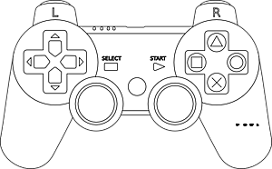

Shift Low

Shift High

SHOOT!

Shooter Up

Shooter Down

Frisbee Flywheels

**Left-Stick**

Up/Down-Left Drive

**Right-Stick**

Up/Down- Right Drive

**VLAD CONTROLS**